**SQL Notes**

What is Database?

Collection of data in a format that can be easily accessed.

What is DBMS?

A software application used to manage our database is called DBMS.

Types of DBMS

* Relational -> Data stored in Tables. Example- MYSQL, Oracle, etc.
* Non-Relational -> Data not stored in tables. Example – MongoDB

What is SQL?

Structured query Language, programming languages used to interact with relational database.

Used to perform CRUD operations:

* Create
* Read
* Update
* Delete

What is SEQUEL?

Structured English Query Language

Note -> Data in the tables in DBMS are always interrelated with each other.

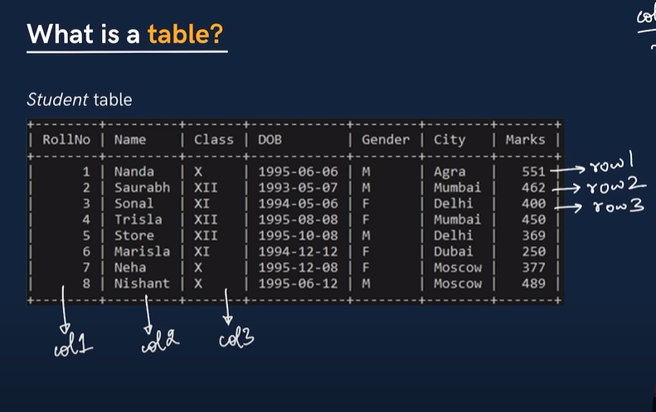

Column -> Structured schema (shows the design of the table)

Rows -> Shows the individual data.

Create and drop database and use database

* CREATE DATABASE xyz;
* DROP DATABASE xyz;
* USE dayabase xyz;

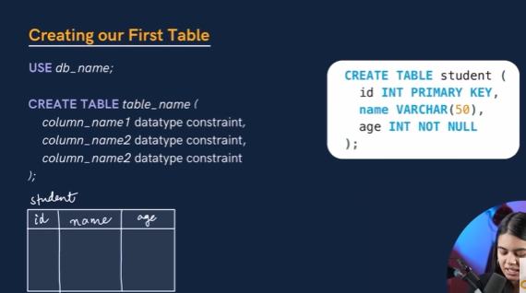

Two more datatypes:

Signed and unsigned

Signed datatypes -> TINYINT (-128 to 127)

TINYINY Unsigned -> (0 to 255)

Basic creating tables and adding data and executing it.

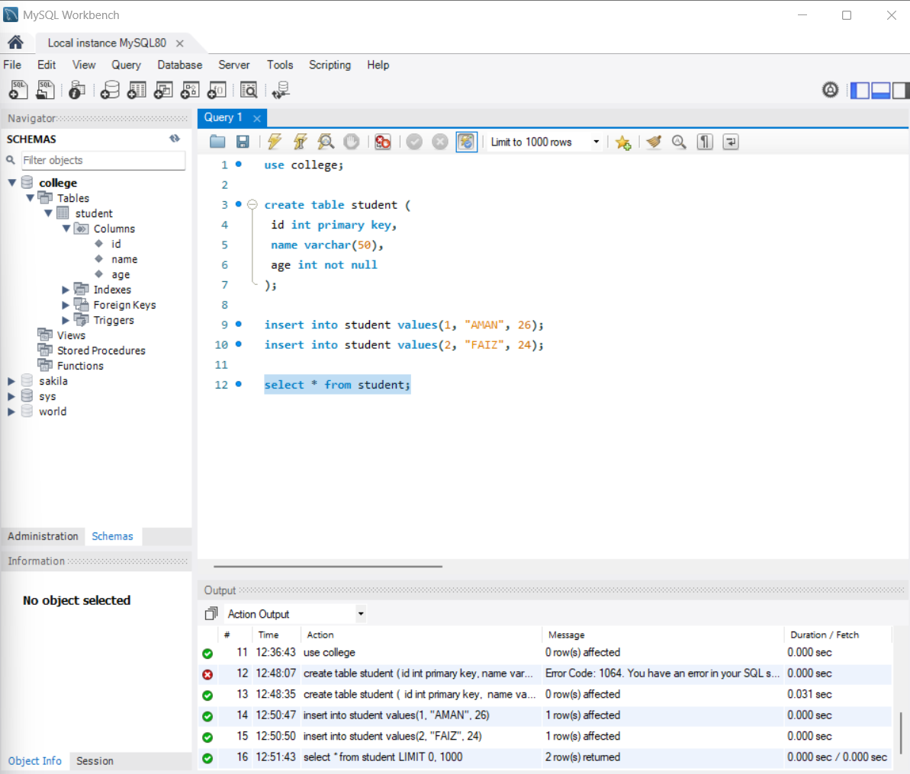

Datatypes

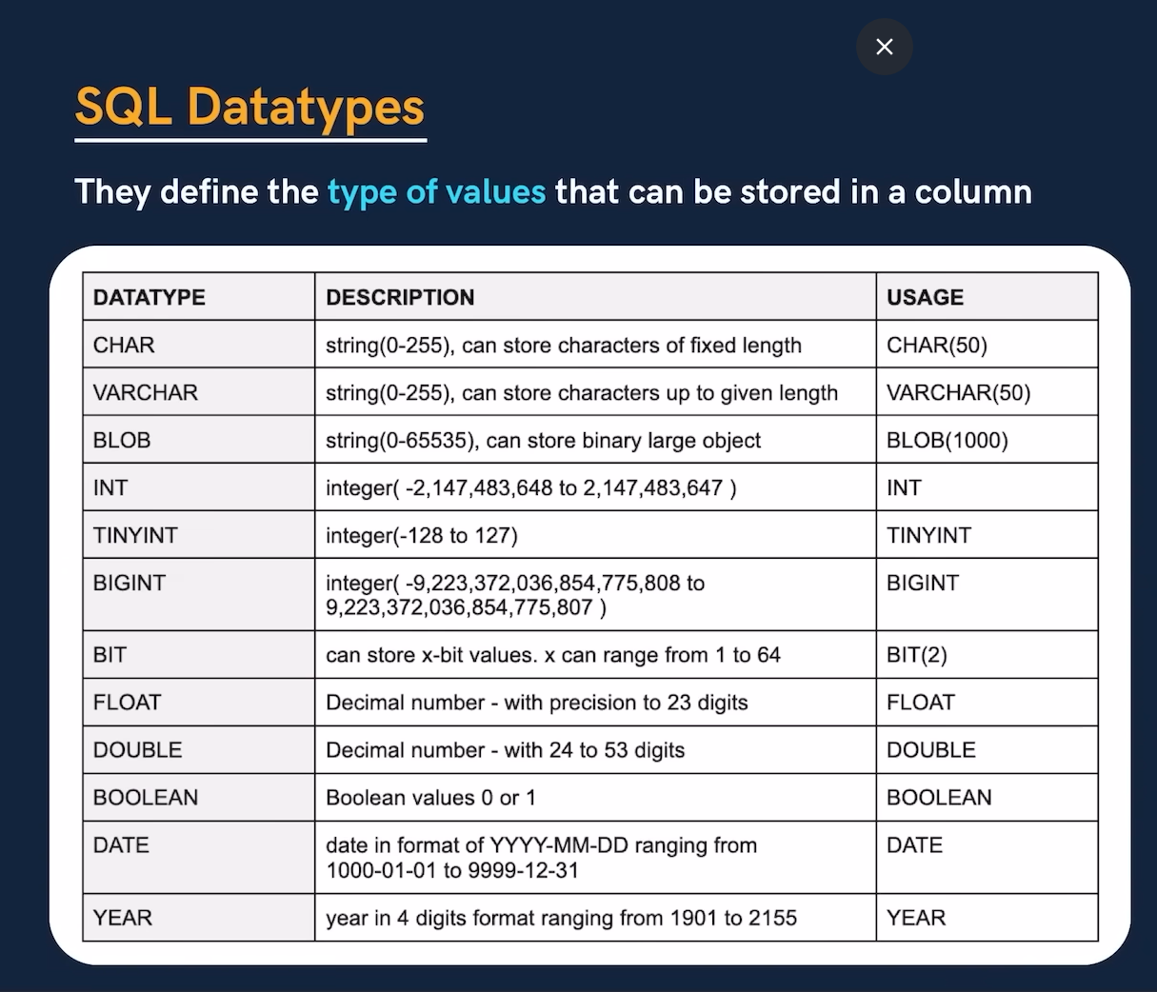

Types of SQL commands

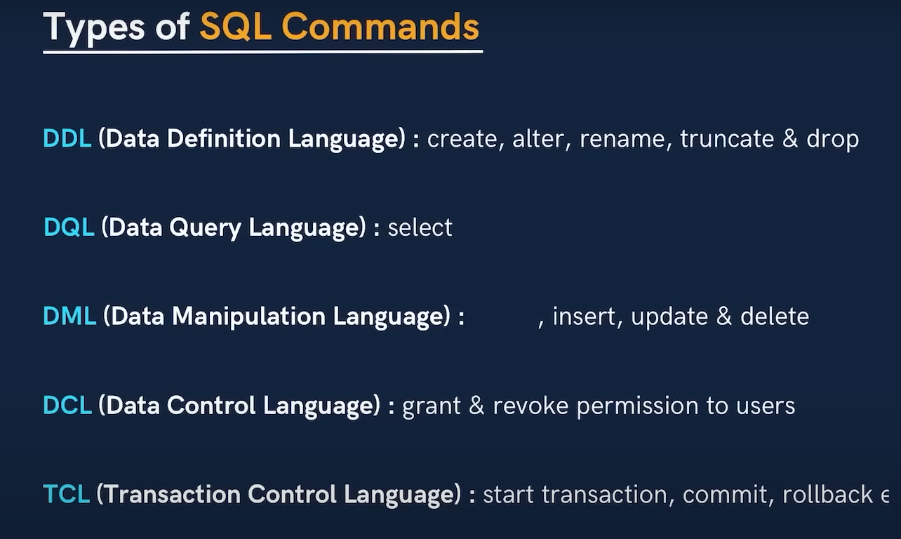

Data related quarries

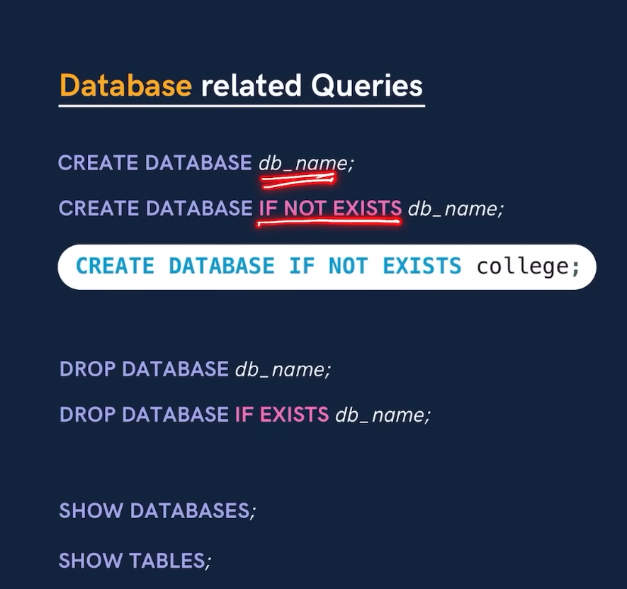

Tables related quarries

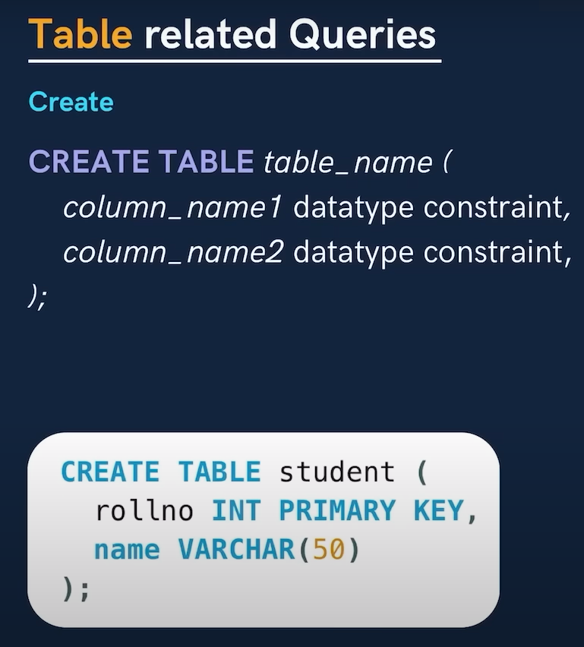

How to view all the tables and data of the made table.

SELECT * FROM table_name; * means all, select all from table_name;

Insert data into tables:

INSERT INTO table_name

(rollno, name )

VALUES

(101, “karan”);

(102, “arjun”);

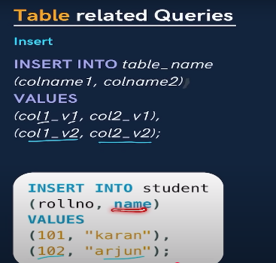

Question

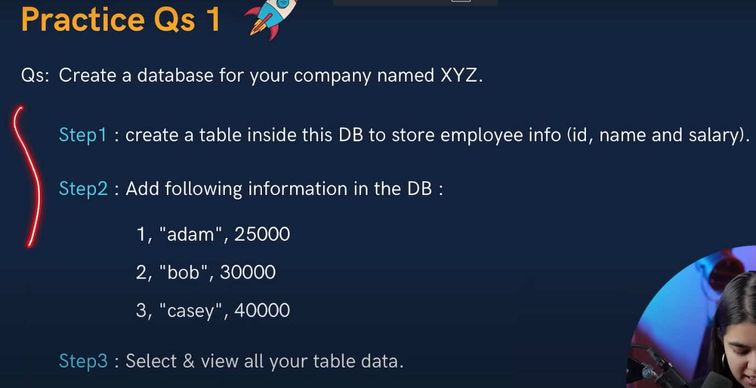

Ans: Code

create database XYZ;

use XYZ;

create table employeeinfo(

id int primary key,

name varchar(50),

salary int

);

select * from employeeinfo;

insert into employeeinfo

(id, name, salary)

values

(1, "bob", 25000),

(2, "adam", 30000),

(3, "casey", 40000);

Result:

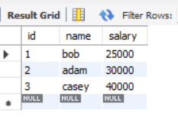

**Types of keys**

**Primary keys:** It is column in the table that uniquely identifies each row. There is only 1 PK.

**Foreign keys:** A foreign key is a set of columns in a table that refers to the primary key of another table. There can be multiple FKs.

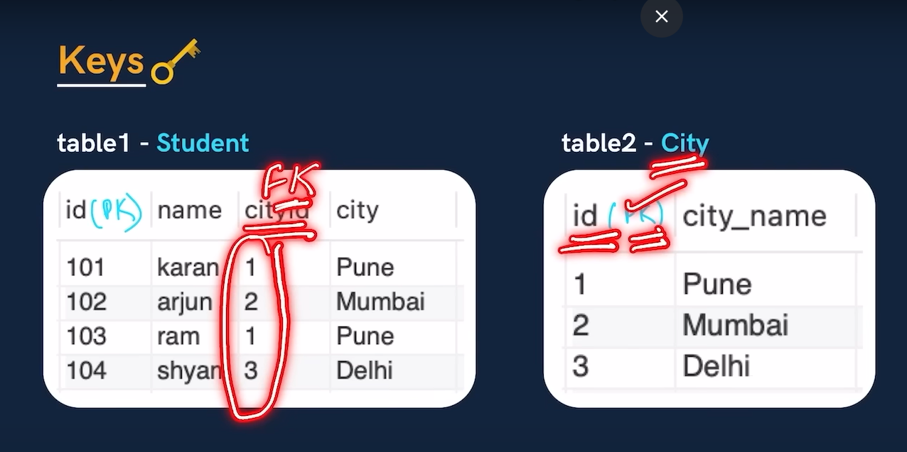

**Constraints**

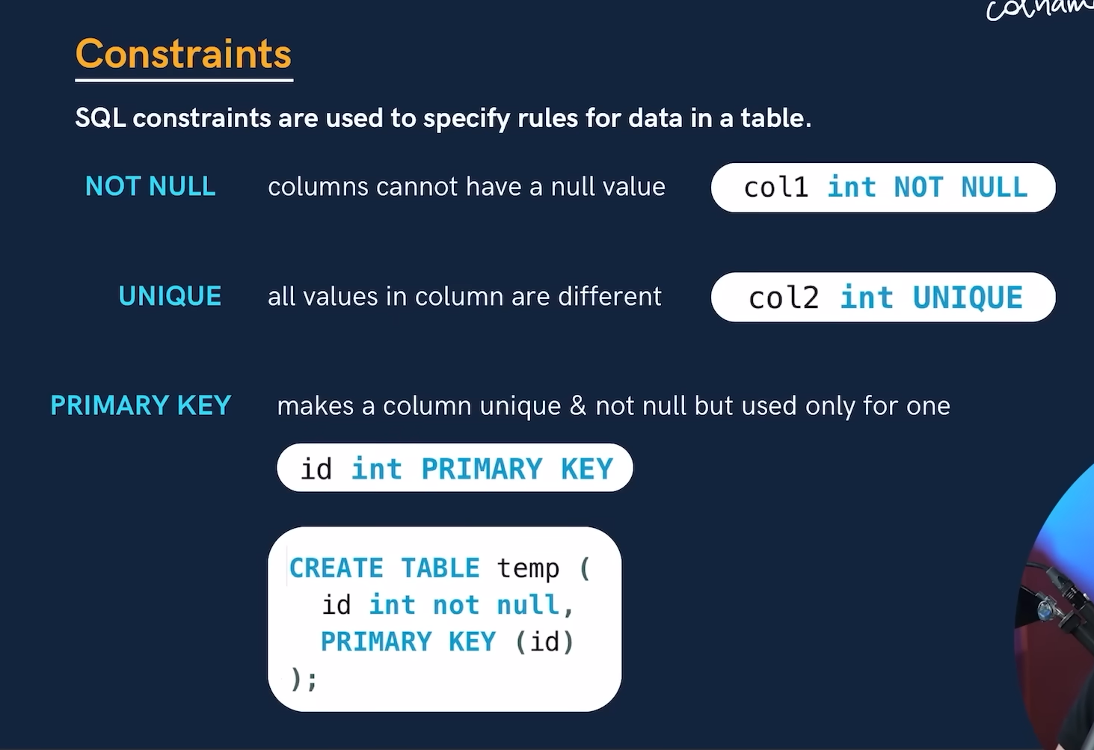

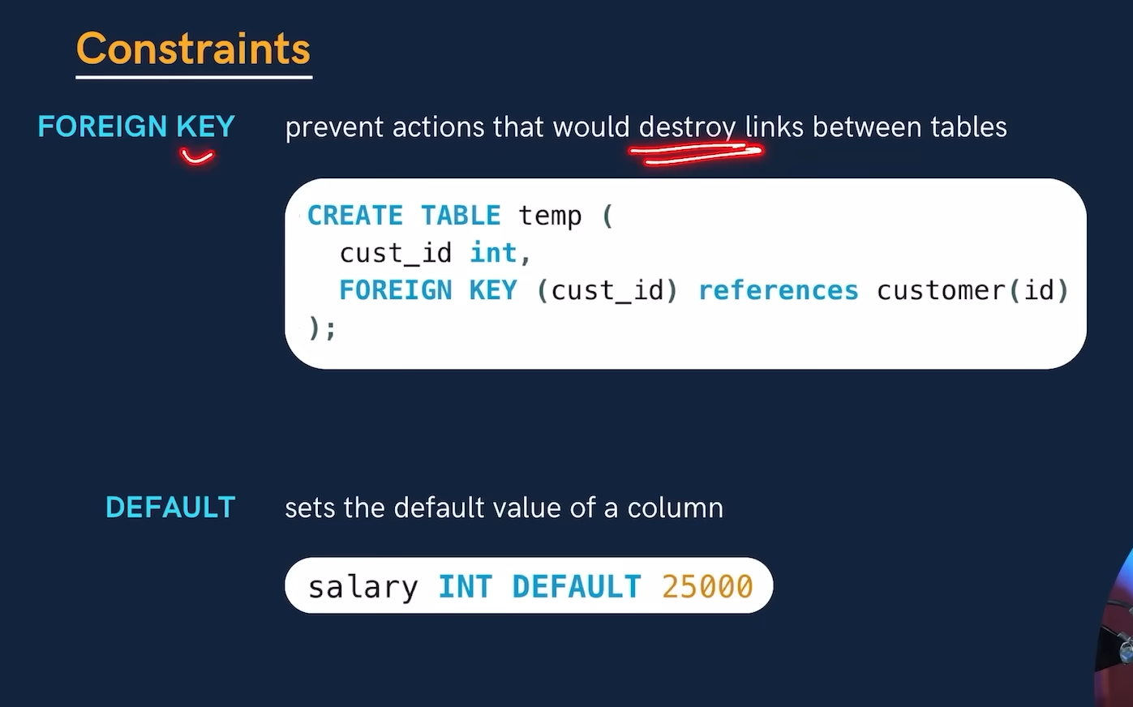

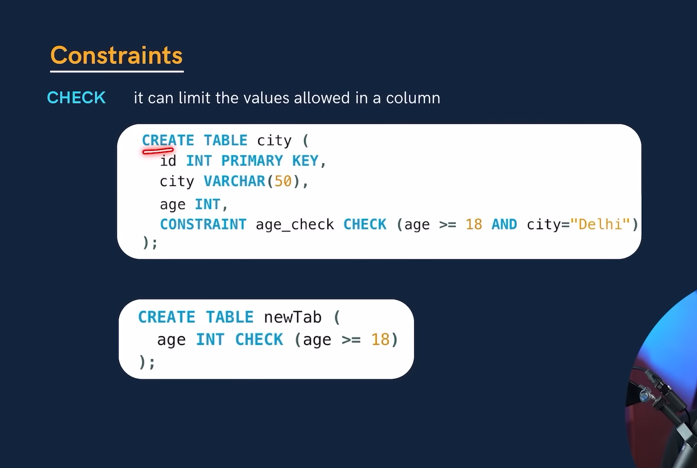

Select in details

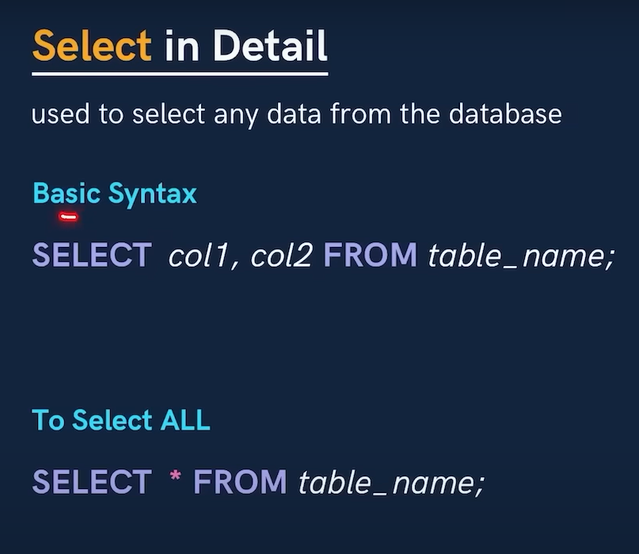

Note -> When we do not need to see the repeated values then, we use the distinct key word.

**Where clause**

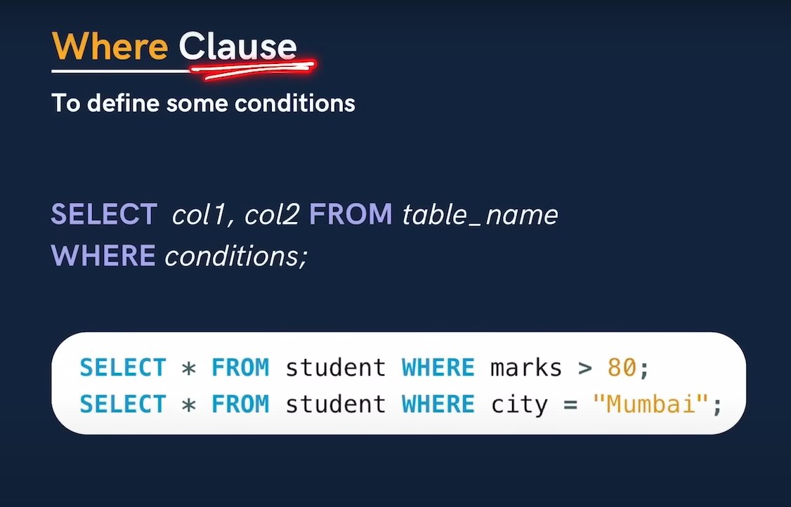

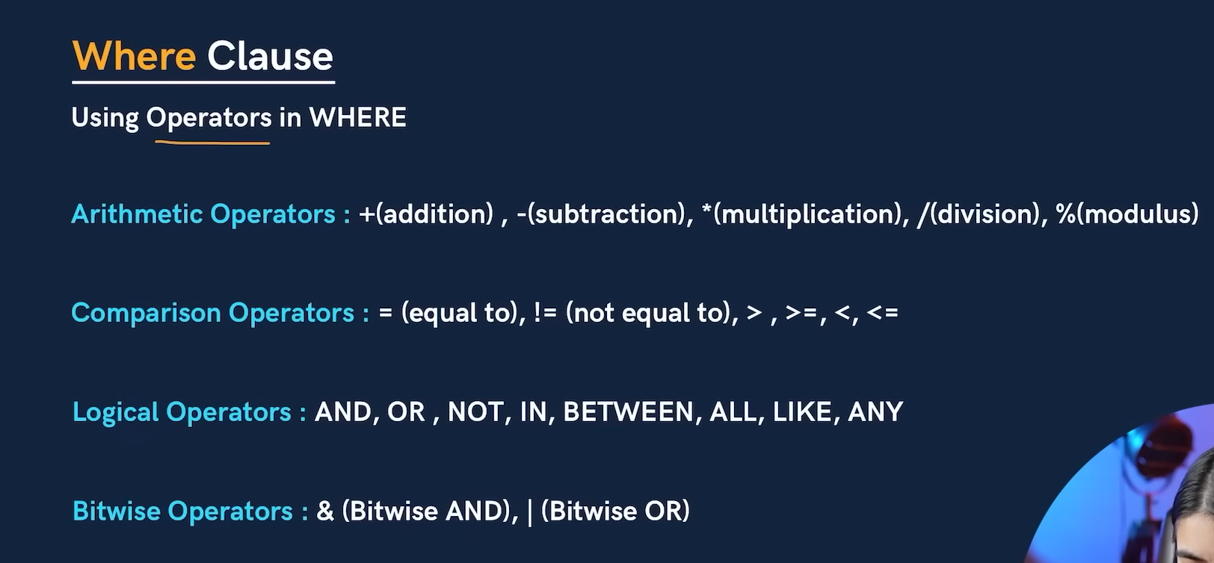

**Operators**

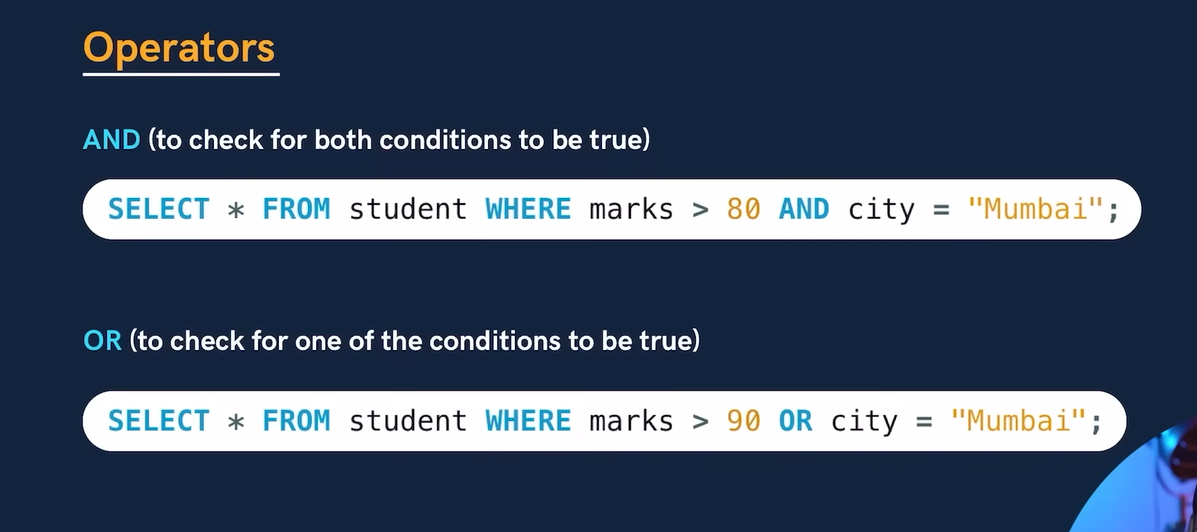

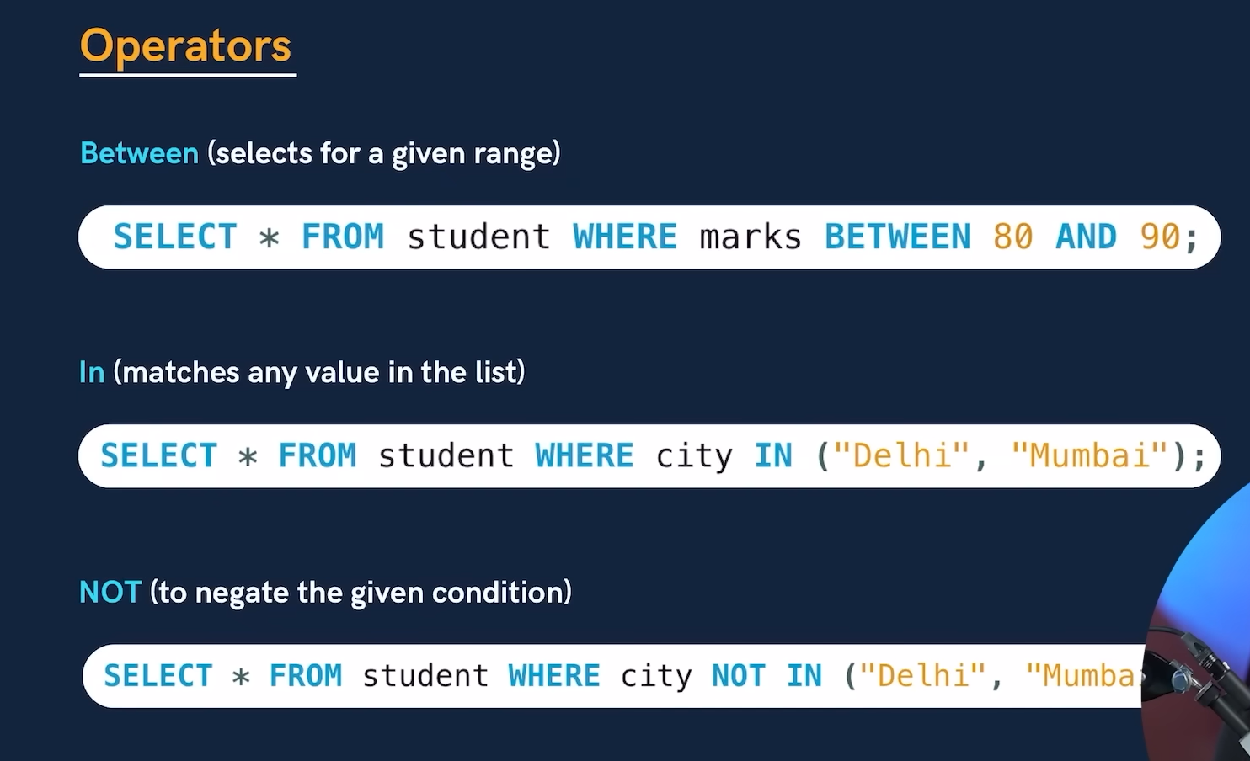

**Limit Clause**

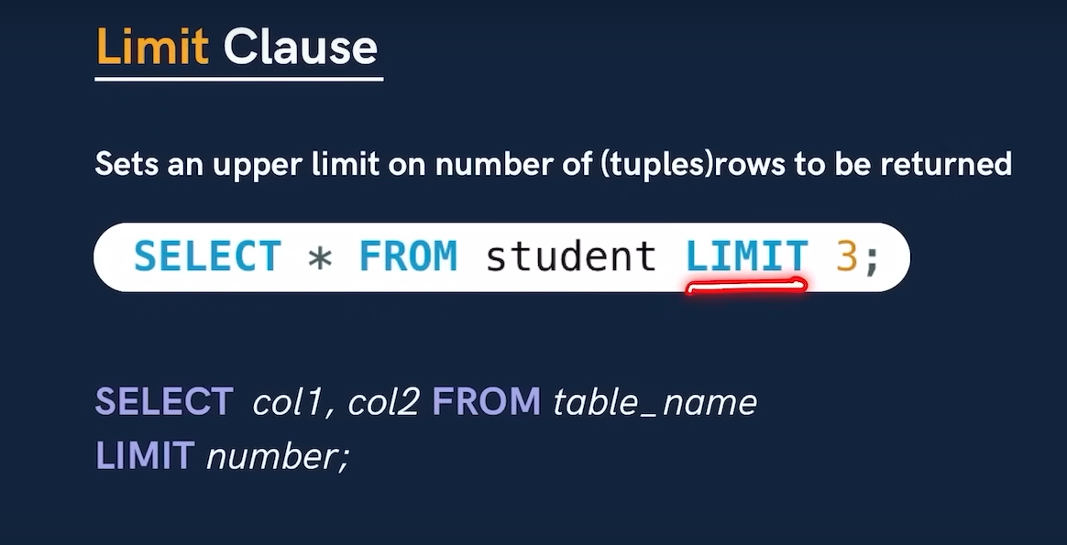

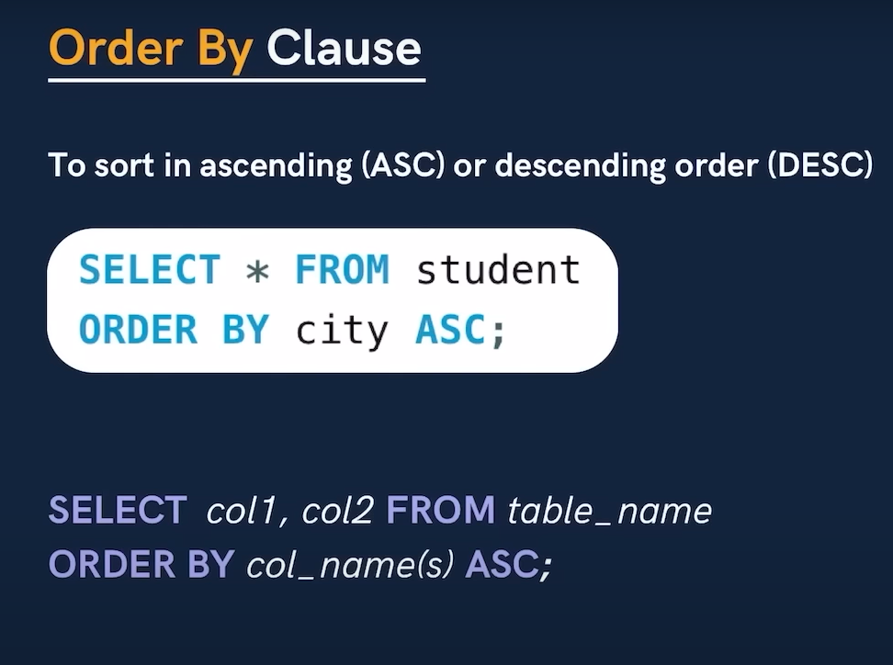

**Functions**

**Aggregate functions:** It performs a calculation on a set of values, and return a single value.

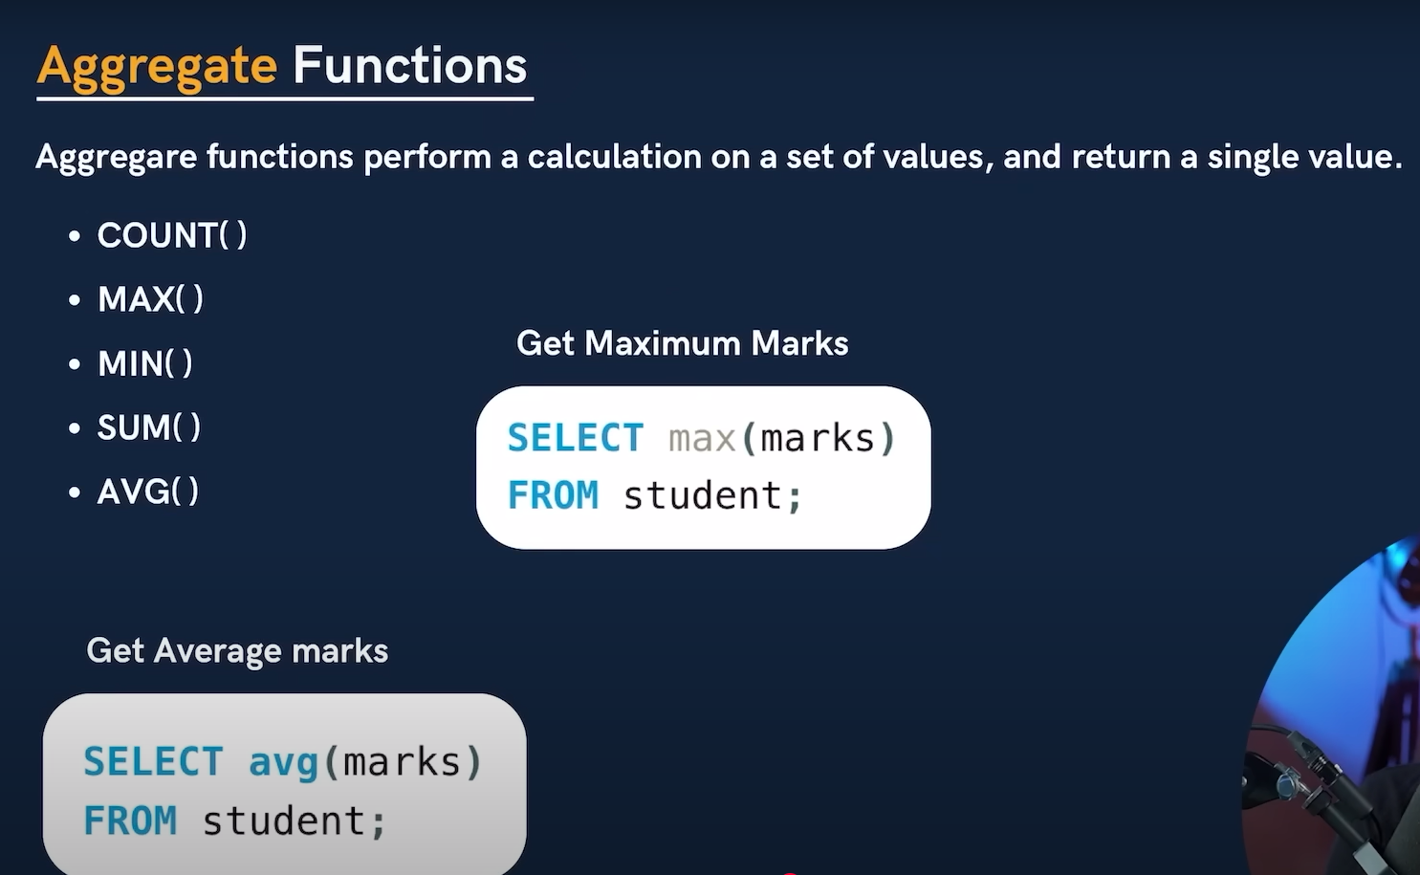

Group by clause

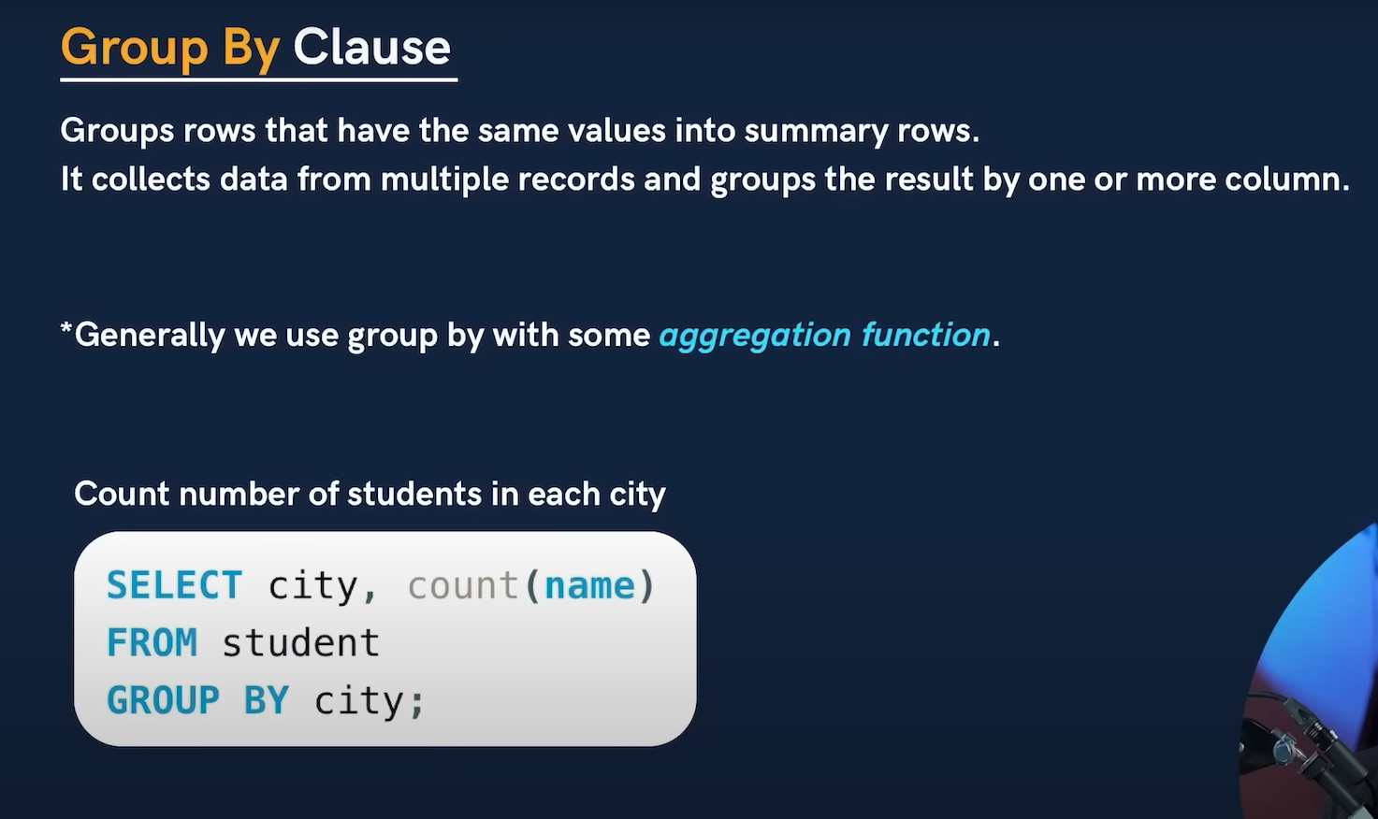

Having clause

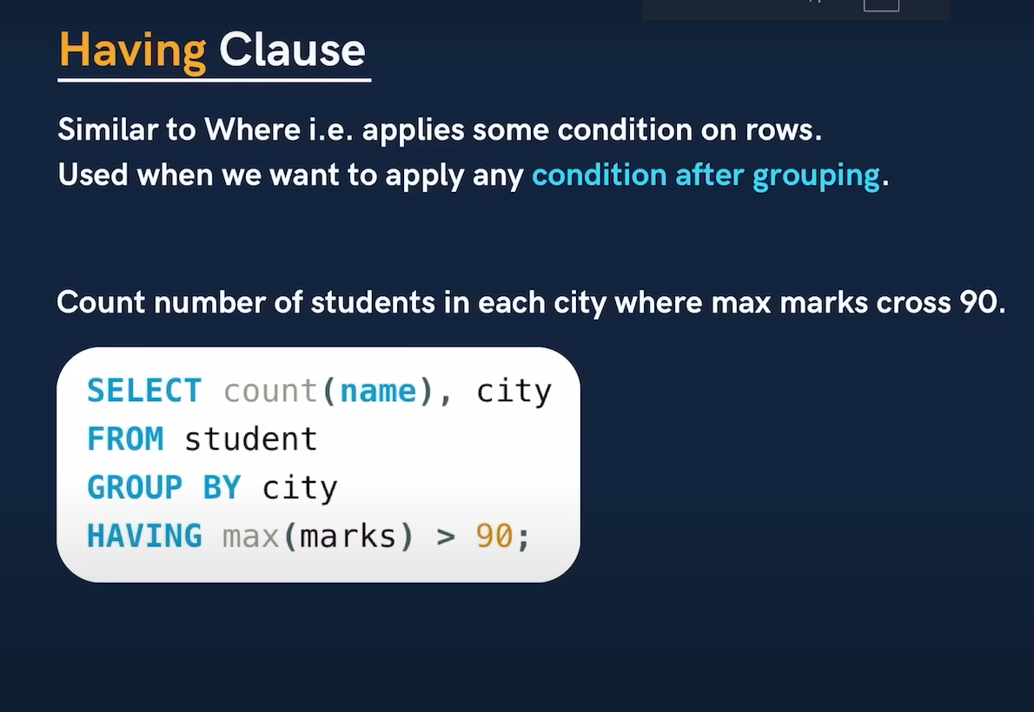

‘Where’ clause is used only for the conditions on rows,

Whereas ‘Having’ clause used to apply the condition on the group.

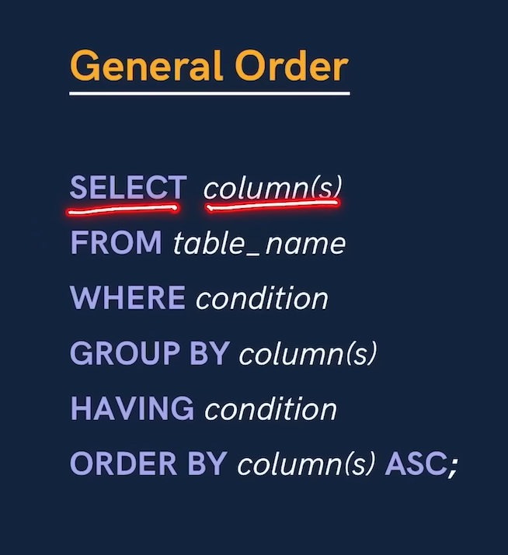

Table related queries

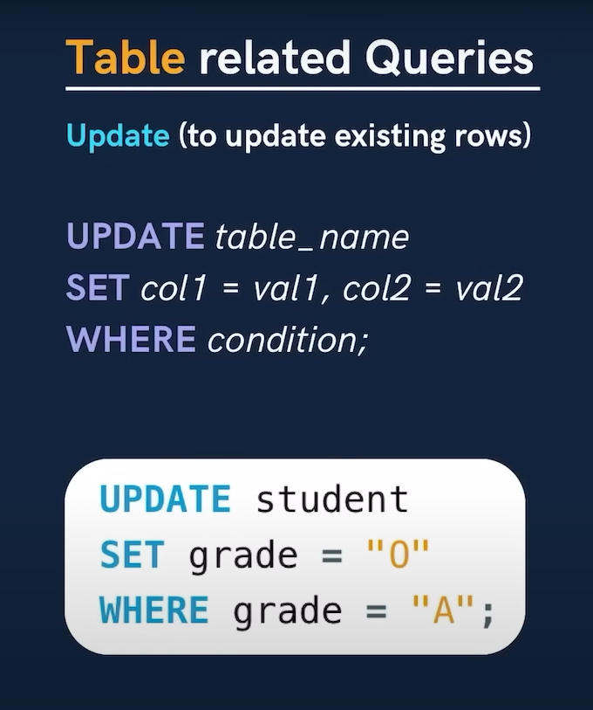

Note -> Safe mode in SQL help to save us from the mistake changes, it is automatically enabled in the MYSQL.

To turn off that option we need to run a command -> SET SQL_SAFE_UPDATES = 0;

And to turn that on run this command -> SET SQL_SAFE_UPDATES = 1;

Table related query (Delete)

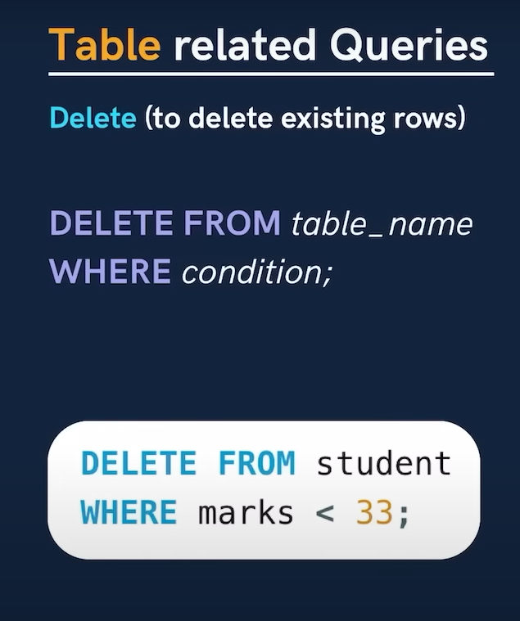

Cascading table

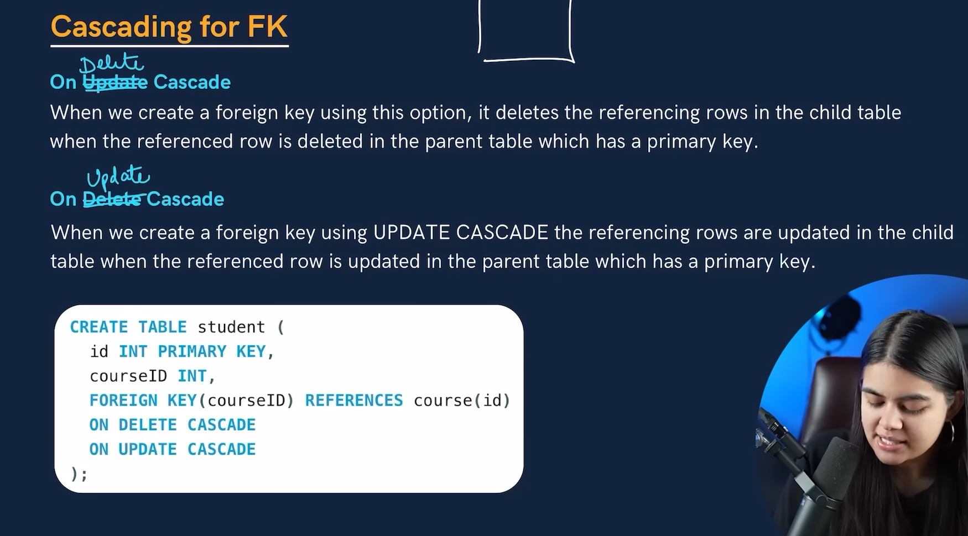

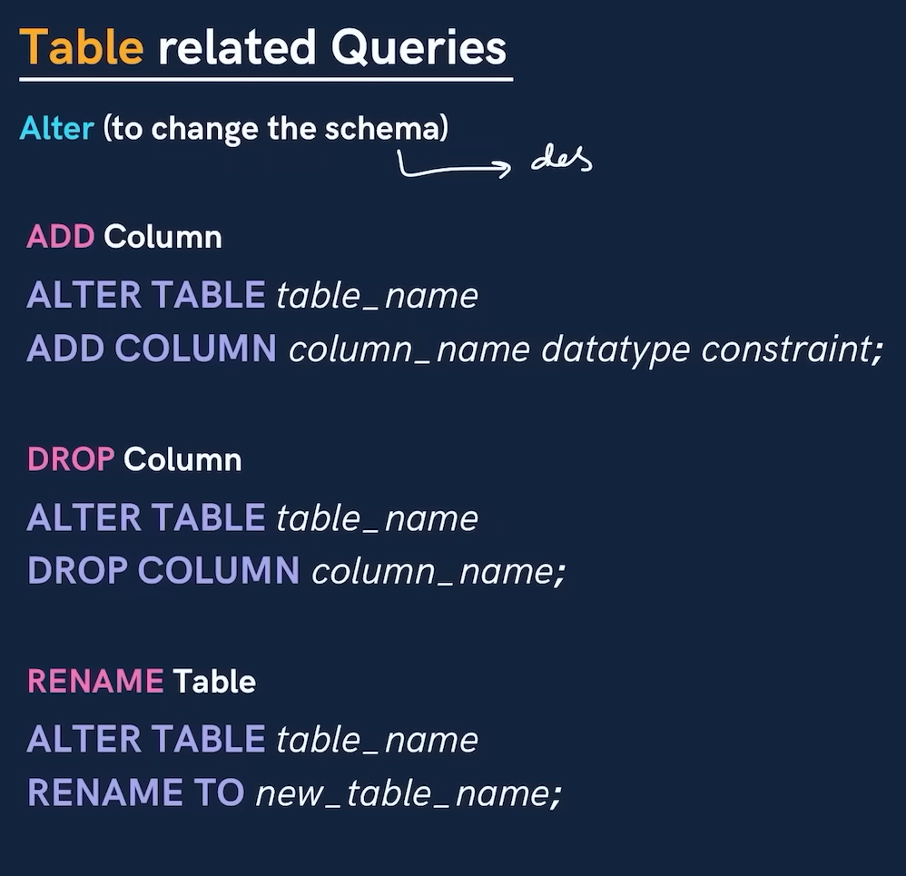

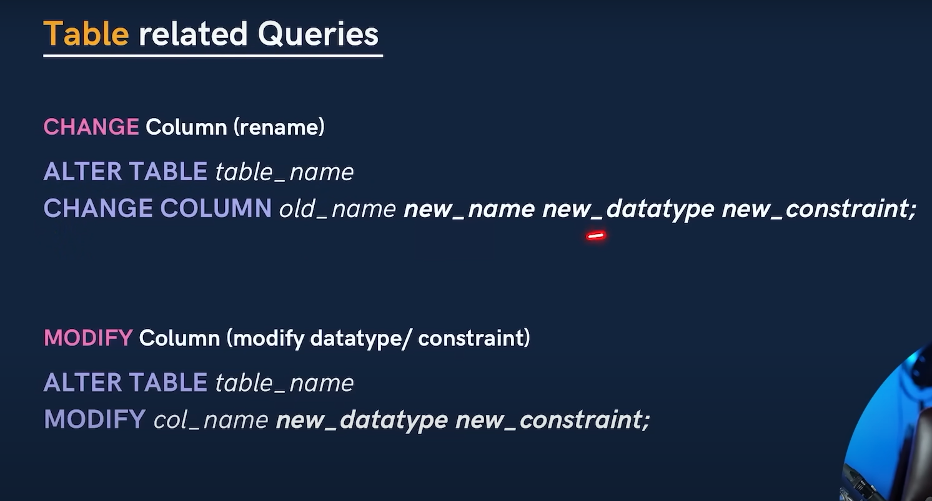

Truncate is used to delete the table’s data

Drop command is used to delete the whole table and the truncate is used to delete the data from the table. And in truncate the table still exist and we can add the new data in that table

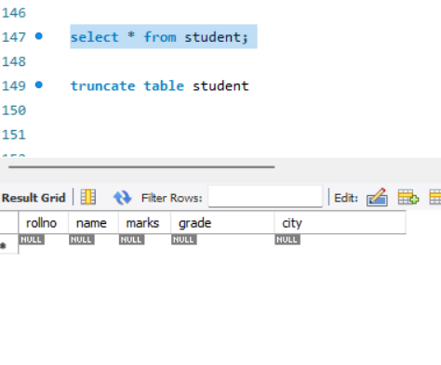

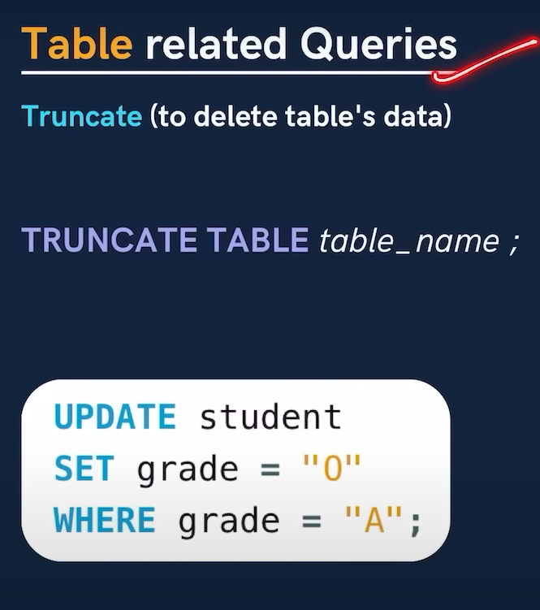

Joins in SQL

Joins in SQL are used to combine rows from two or more tables, based on a related column between them.

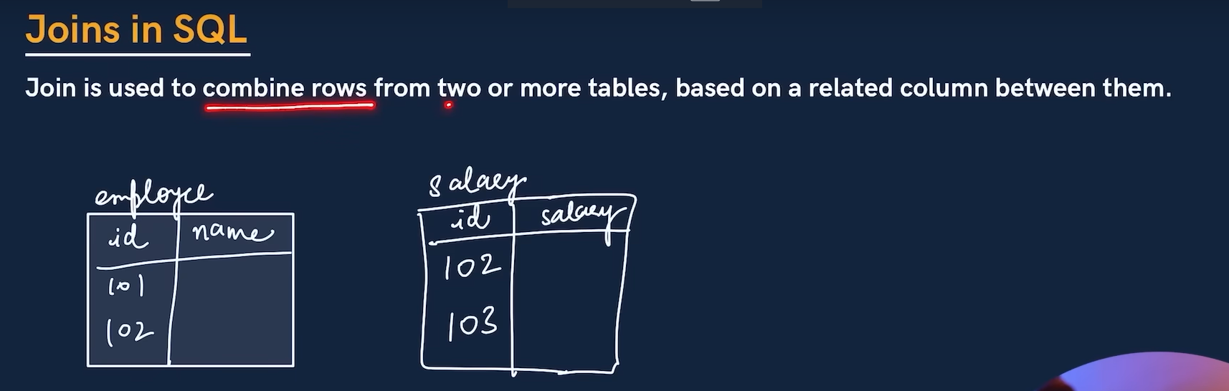

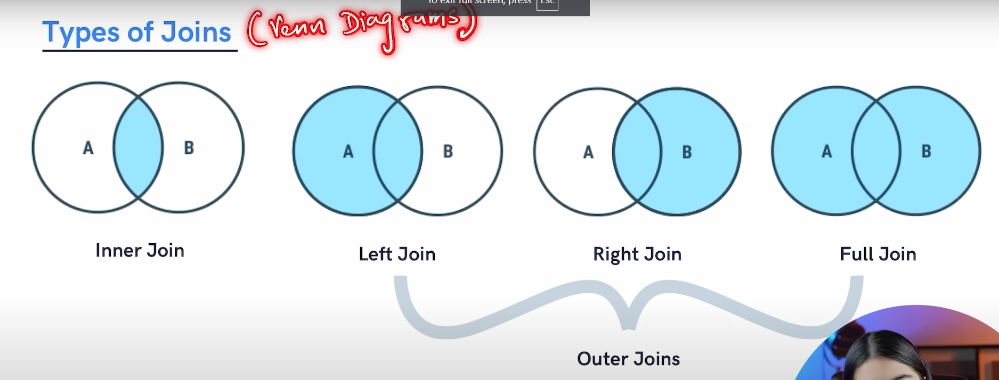

Inner join

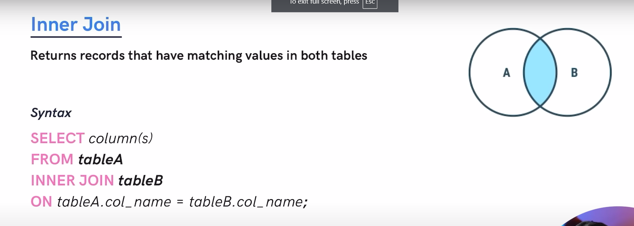

Example of inner join.

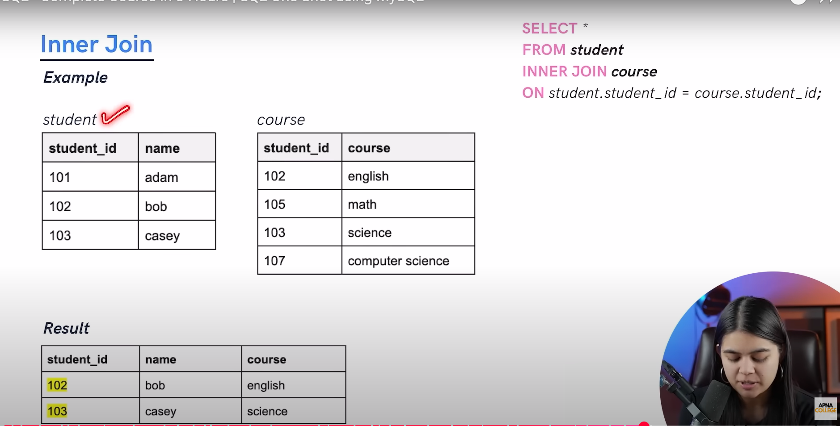

Left join

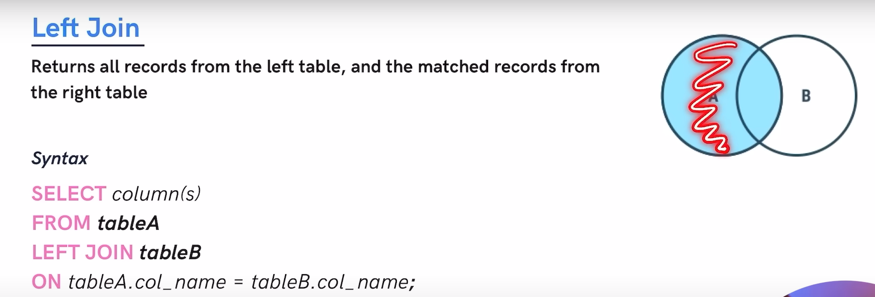

Example of left join

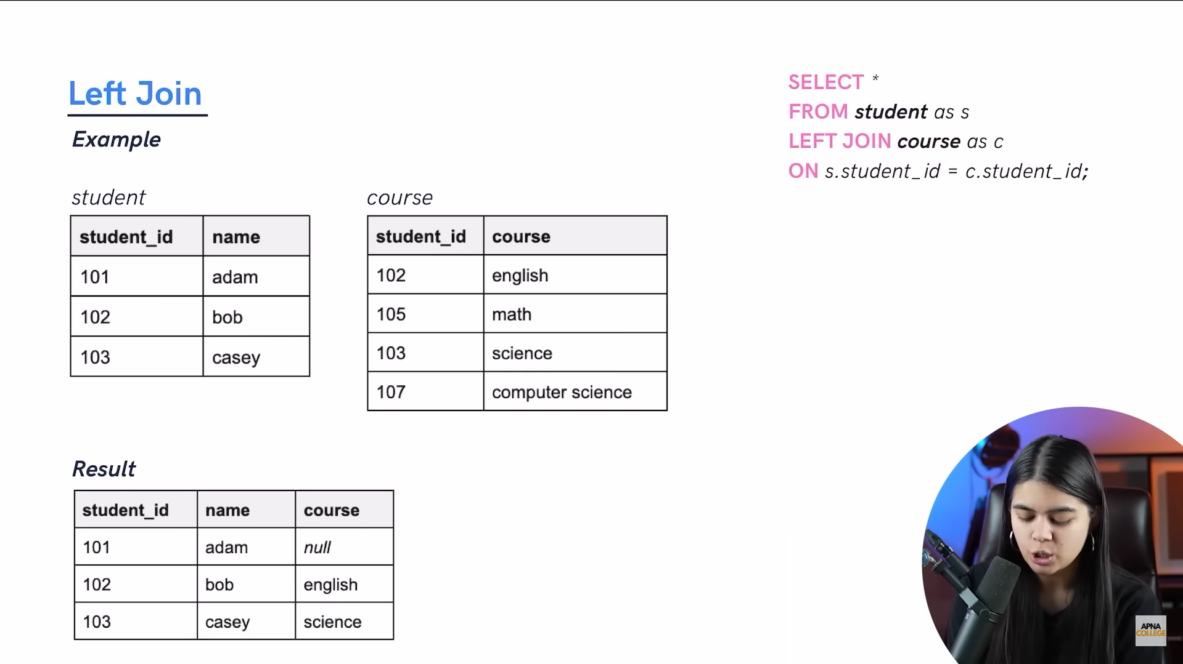

Right join

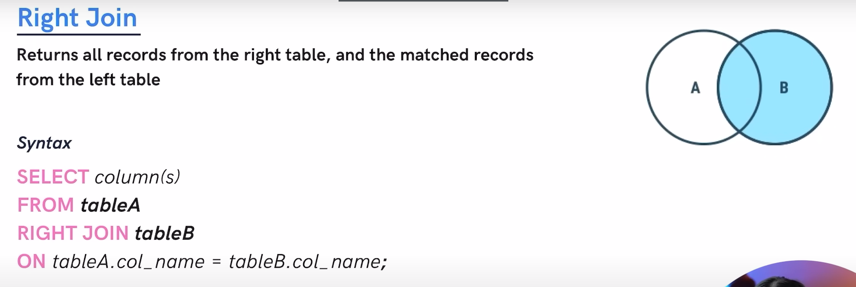

Example of right join

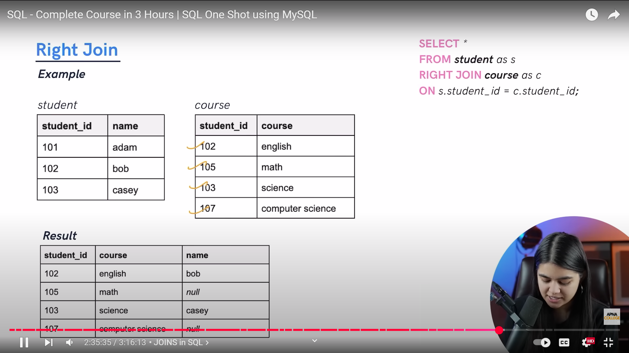

Full join

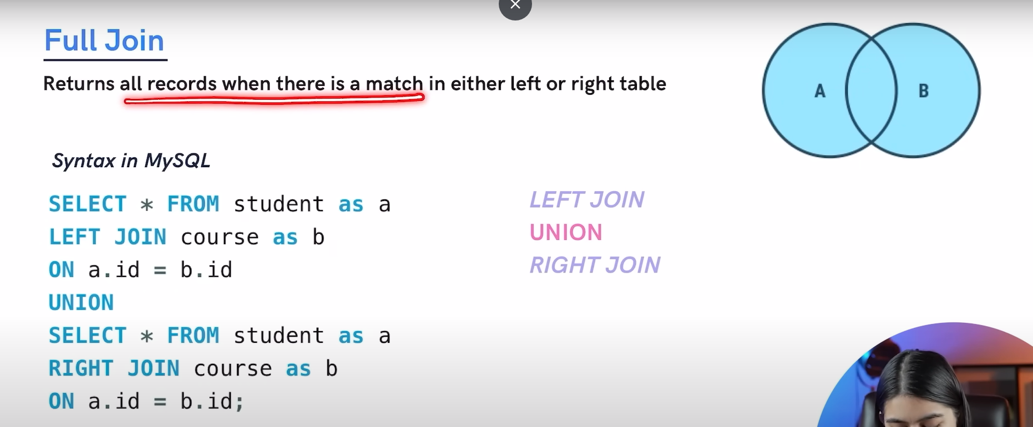

Example of full join

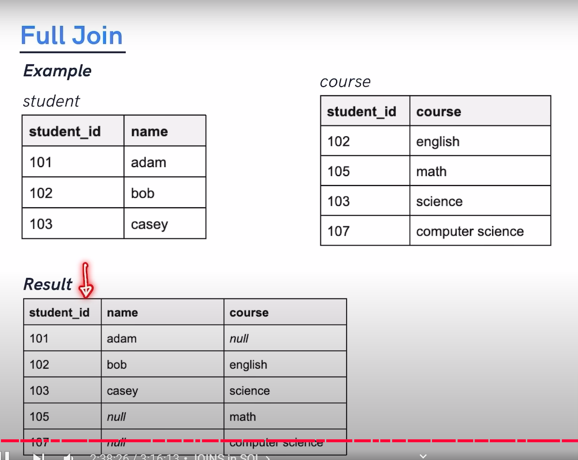

Some extra kind of joins

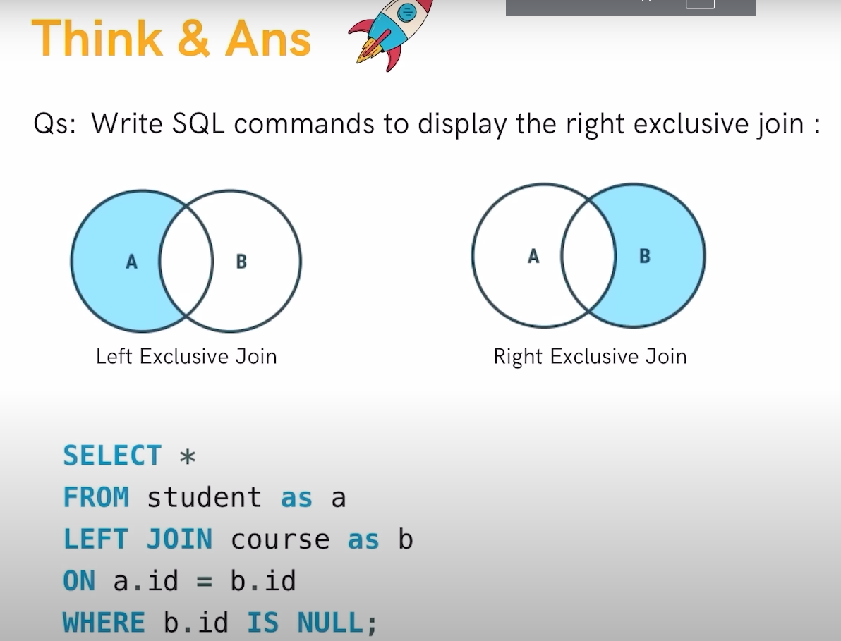

Self-join

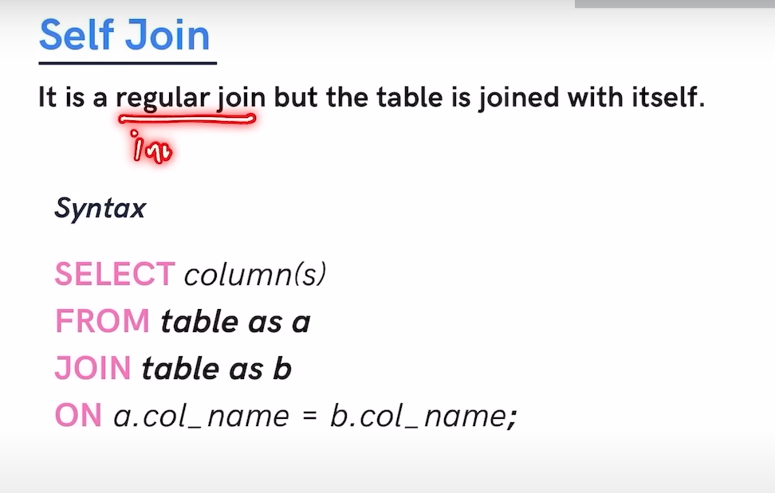

Example of self-join

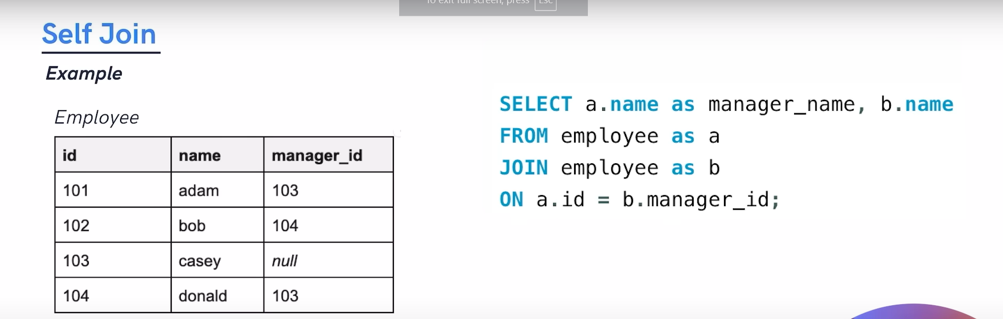

Upper written code is not acceptable down written code is acceptable.

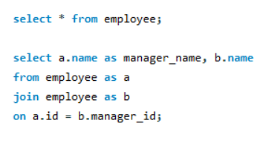

Union: It is used to combine the result-set of two or more SELECT statement gives UNIQUE records.

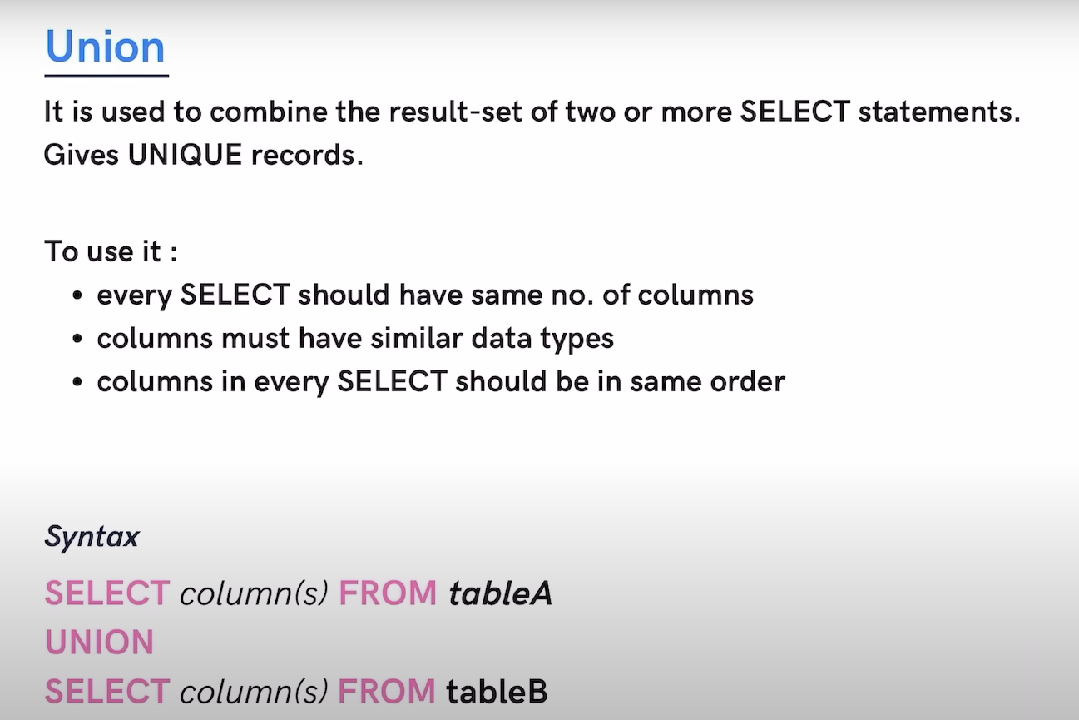

SQL Sub quarries

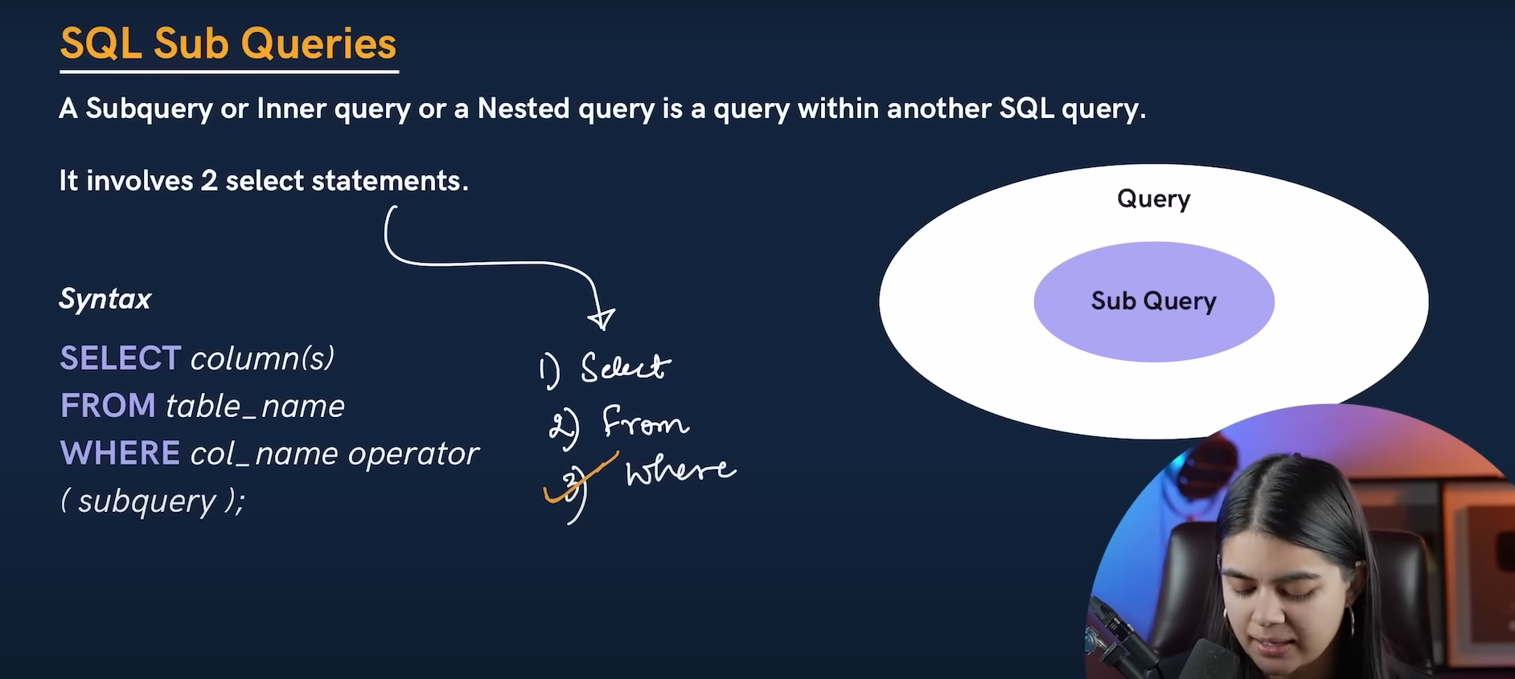

Example of sub query

